Online Tutoring Quick Reference for Students

You must be logged into Moodle in order to access Online Tutoring.
Once you log into the Wilson Community College Moodle site, you will be at the “My Courses” page.
Click the “close” button in the top right to go back to the Wilson CC Moodle home page.
Scroll to the bottom of the page and click the “NetTutor Online Tutoring” link in the footer section.
The Tutoring and Referrals page will launch in a new window displaying a list of the courses you are currently enrolled in.
Click the “Get Tutoring” button next to the course you need tutoring in.
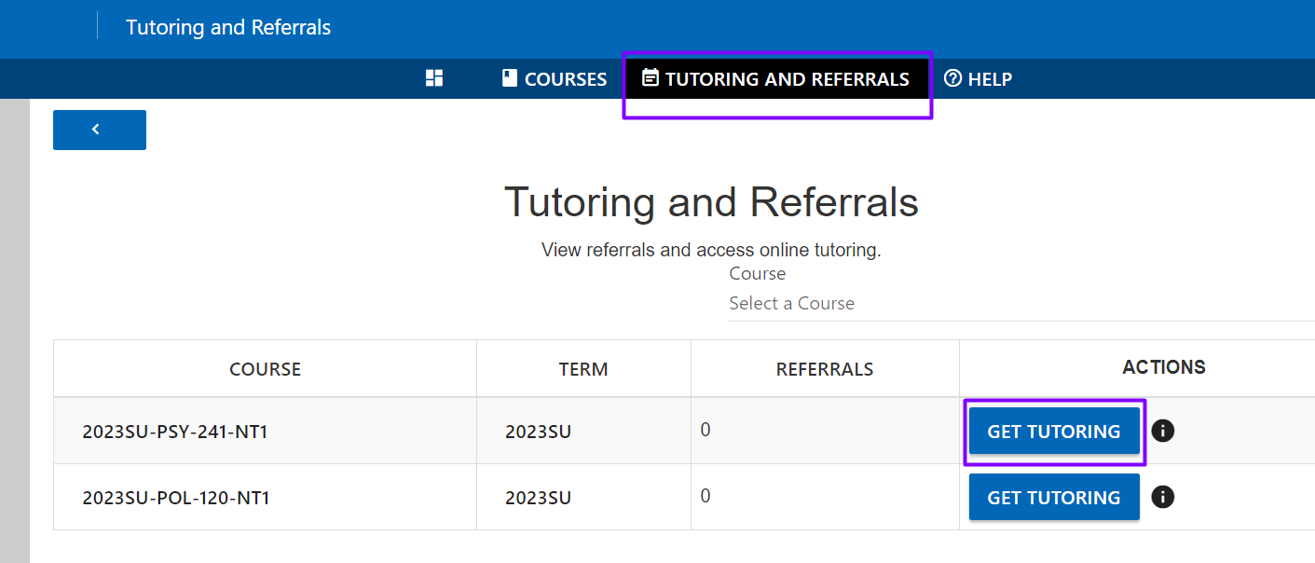
If this is your first visit, you will need to click “I agree” to accept the terms of using this service.
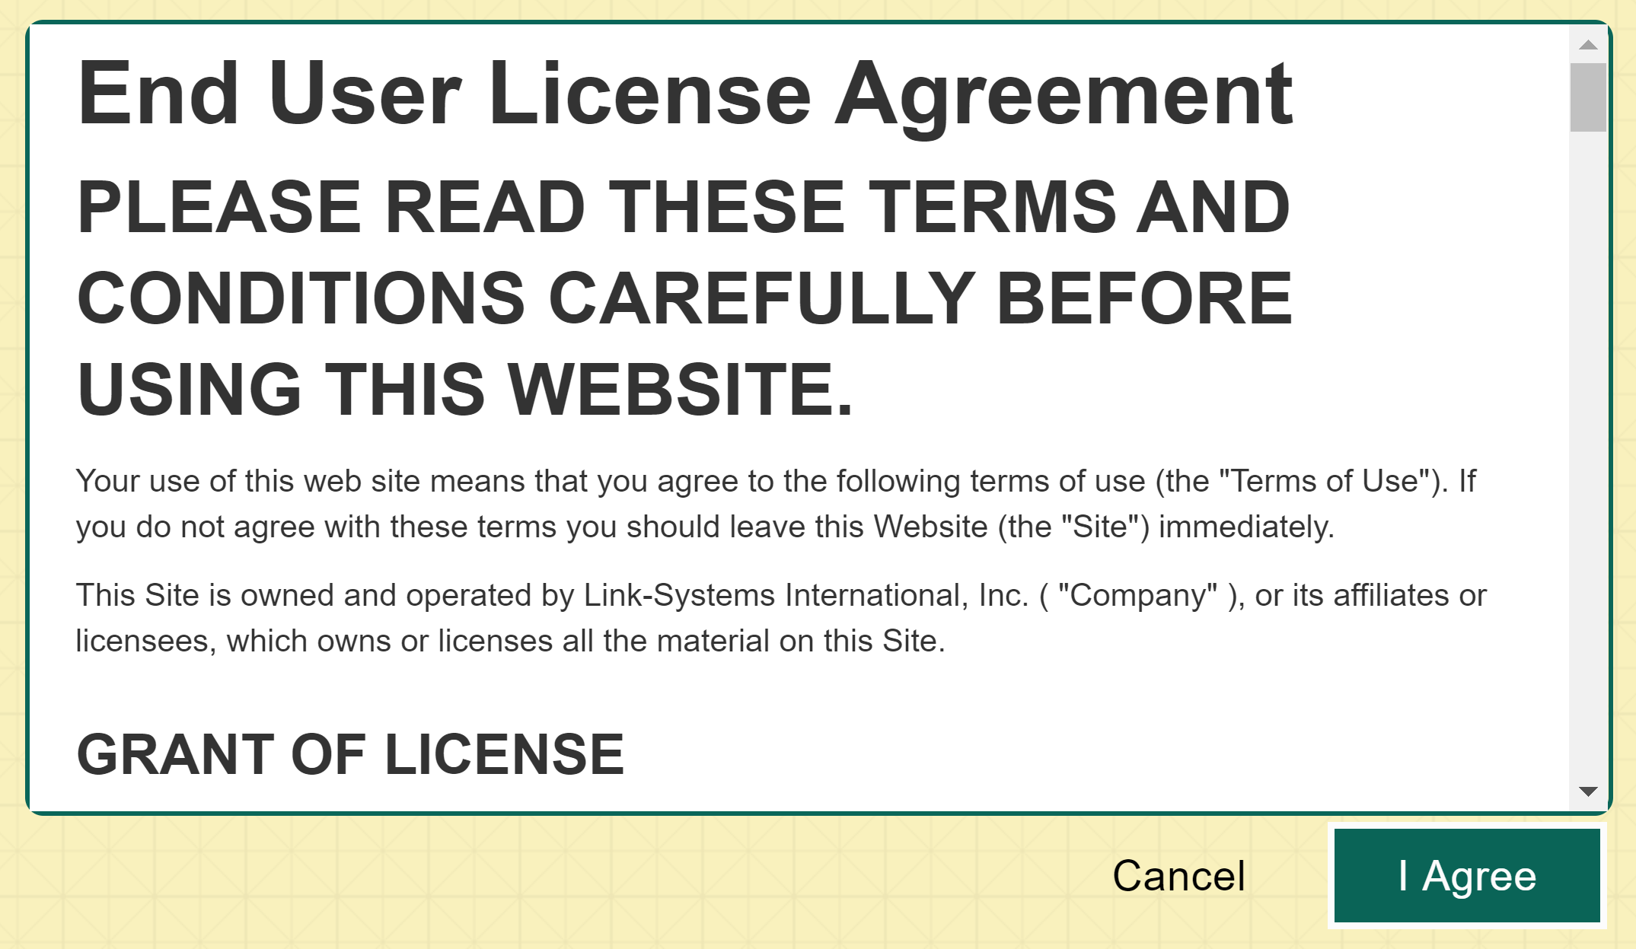
NetTutor Note: Depending on which course(s) you are enrolled in, you may have access to a subject tutor, however, some courses do not have subject-level tutors and only have Paper Center support.

