Submitting a Video for an Assignment
How-to (using ScreenpPal)

- Once you have an account with ScreenPal (it’s free) and are logged in, choose “Make a recording.” This action will open the Video recorder.

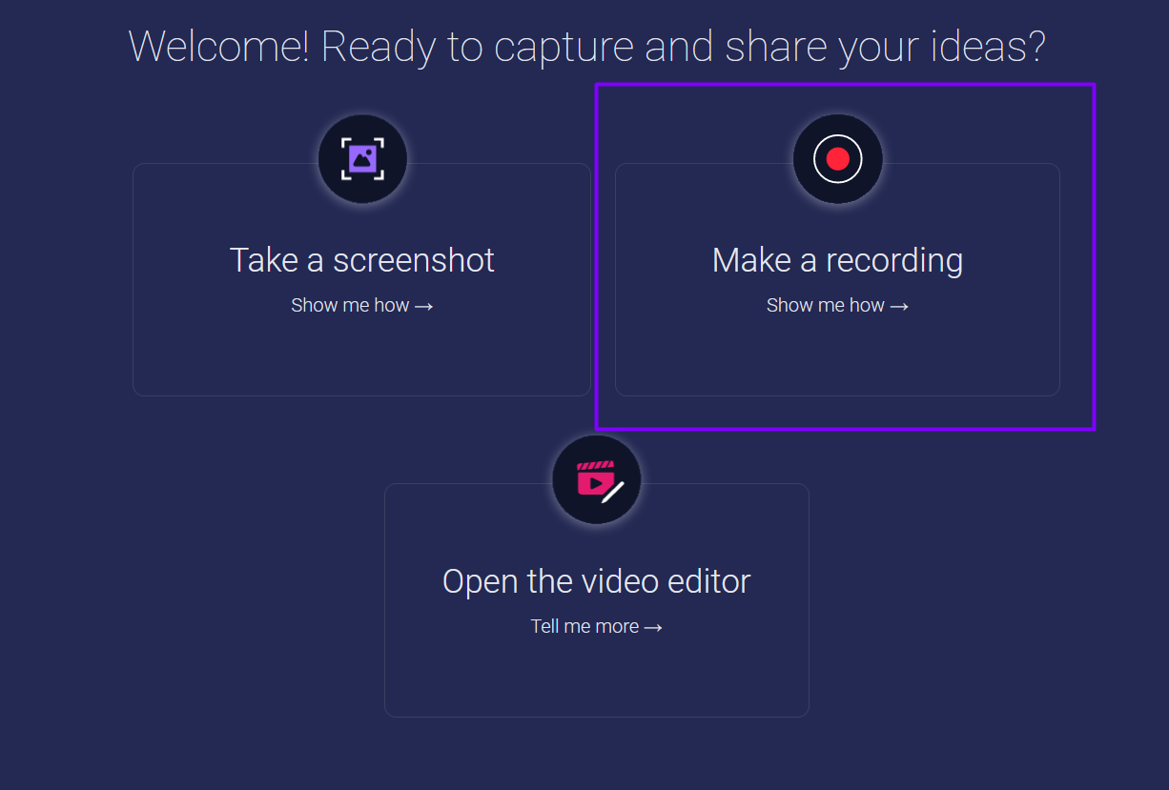

- The recorder will automatically choose to make a screen recording, but you can also choose to record yourself or both your screen and self. You can explore other options if desired, but as long as ScreenPal has access to your camera and mic, those settings aren’t necessary to adjust.
- 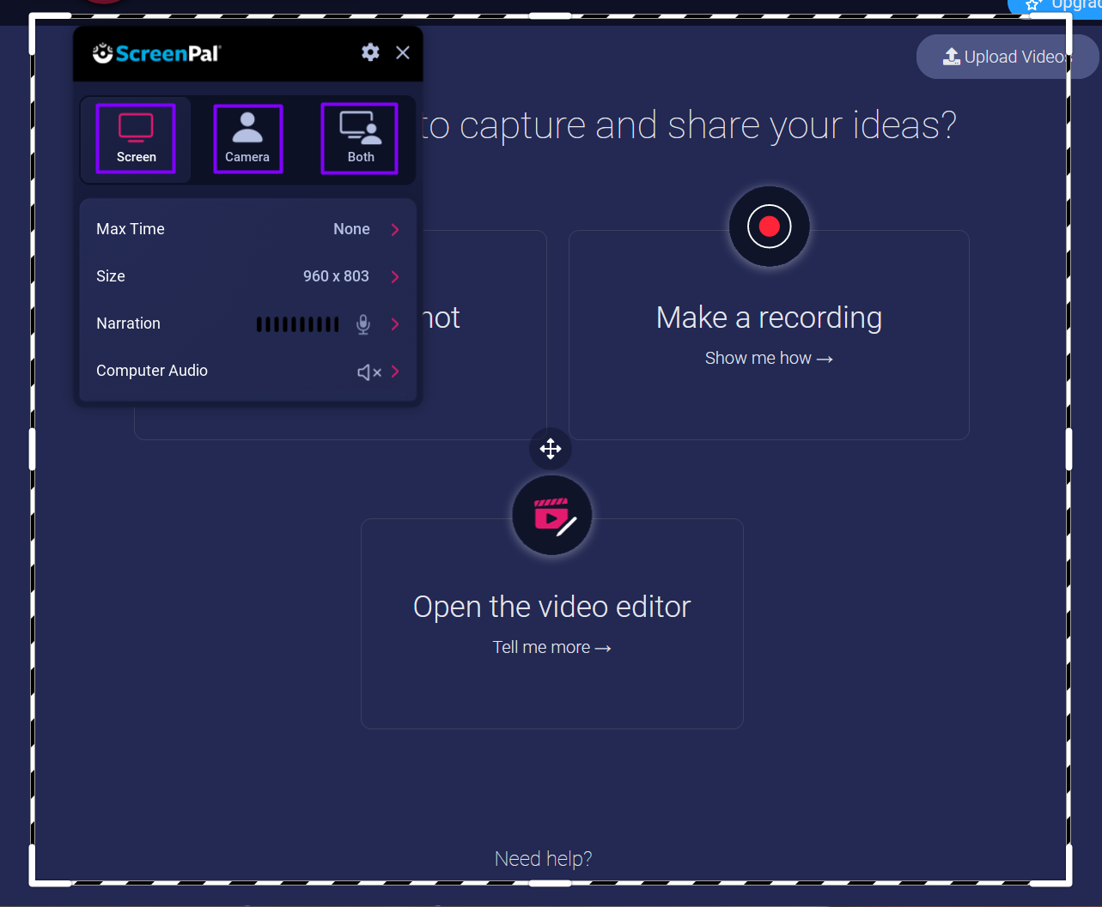

- Once you’re ready to begin recording, click the “REC” button at the recorder's top.

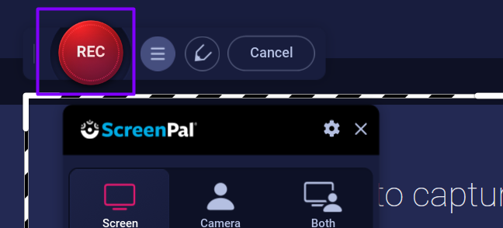

- When you’re finished recording, click the “Pause” button. If you’re satisfied with your recording, choose the “Done” button.

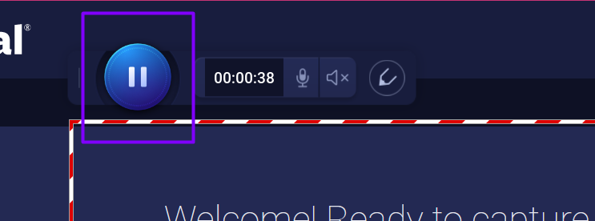
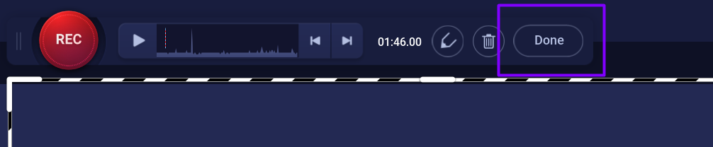

- Clicking “Done” will bring you three different options to save/upload to ScreenPal for later access. You could do a quick share, where you can upload and get a link to share. If you want to edit your video before completing your assignment, choose “Edit Video.”

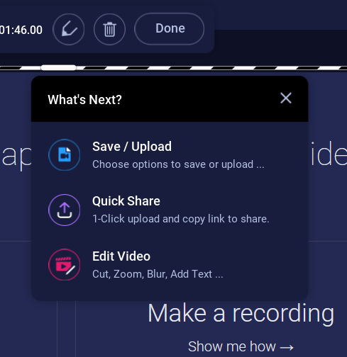

If you choose “Save/Upload”
- If you choose “Save/Upload,” you’ll receive the options below. You can upload to ScreenPal and get a link to submit using Online Text (if your instructor has made that an option). “Save as video file” to upload a file to your Moodle assignment.
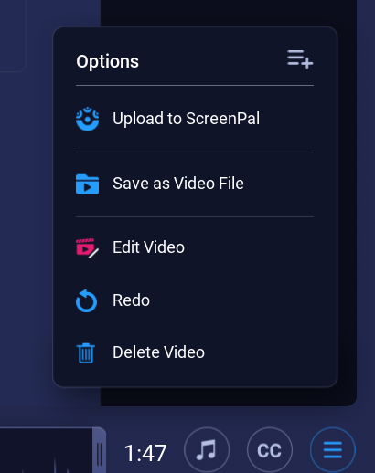

If you choose “Quick Share.”
- If you choose Quick Share, the video will automatically begin its upload, and a link will automatically be copied to your clipboard. However, you can choose to “Copy Link” to be sure. Then, use your link to submit your assignment in Online Text if your instructor has made that a possibility for the assignment.
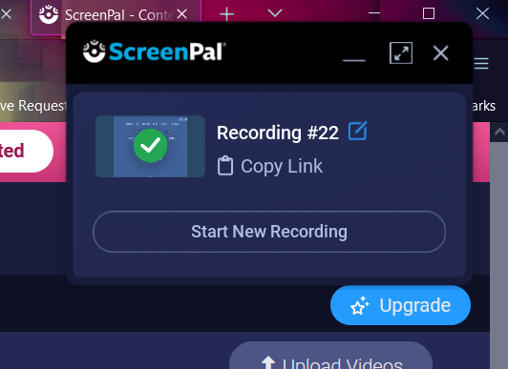

If you choose “Edit Video.”

- If you edit your video before finishing, you’ll get editing options such as renaming the project, cutting parts of the video, and more.
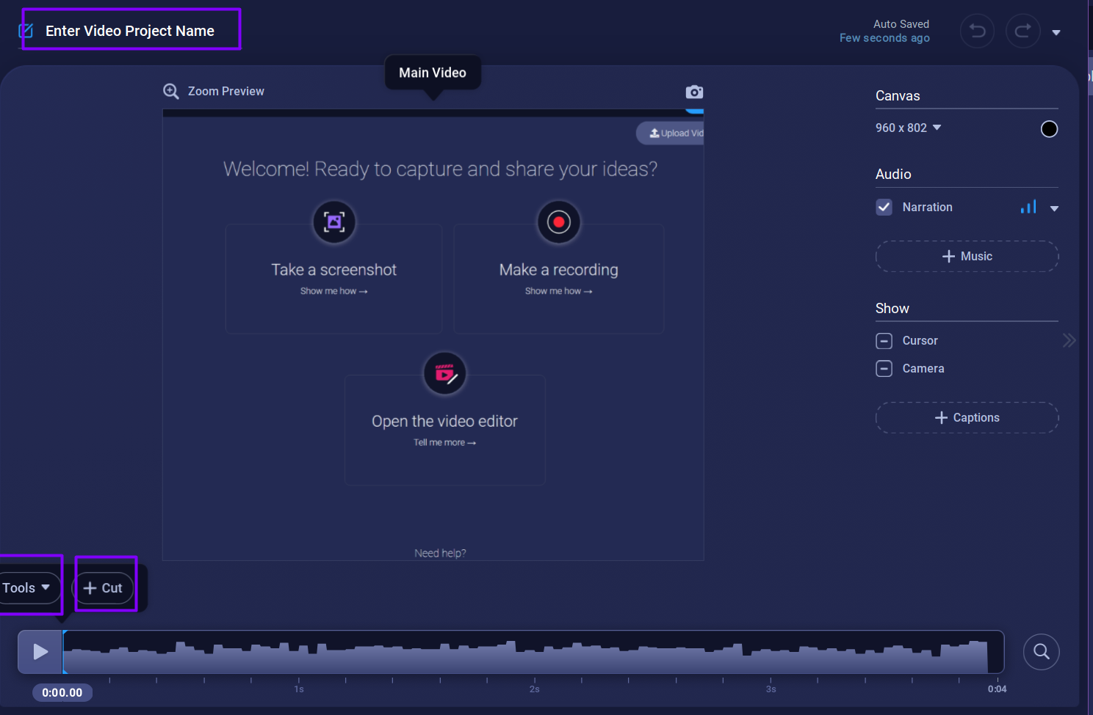

- After editing, click “Done editing video” and return to the “Options” menu.
